IST769 Homework Submission Template

Basic Information
Your Name: Holden Herrell
Your SUID: 502591291
Your Email: hwherrel@syr.edu
Date Due: 10/13/2019
Homework #: 2

Instructions
For each answer, please include your answer as text, and any screenshot(s) which demonstrate your answer was executed. Most importantly, make sure to include evidence your answer is correct. This will most likely be a screenshot. If you had issues, problems, or had to make assumptions include them in your answer.

Your Answers:
I was travelling last weekend and unexpectedly did not have internet connection where I was staying—hence why this was not submitted by the deadline. I took my best attempts and then used the synchronous video to see where I could improve my code or get “unstuck” if I got hung up on something.
1. 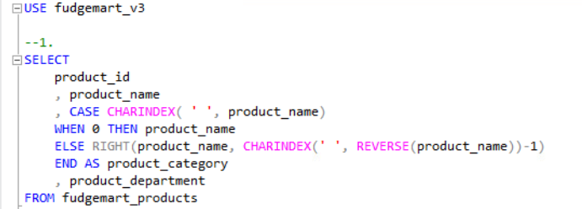
I was able to get really close to this answer without help from the synch, but I was stuck on the part where I wasn’t able to account for products that were only one word.
2. 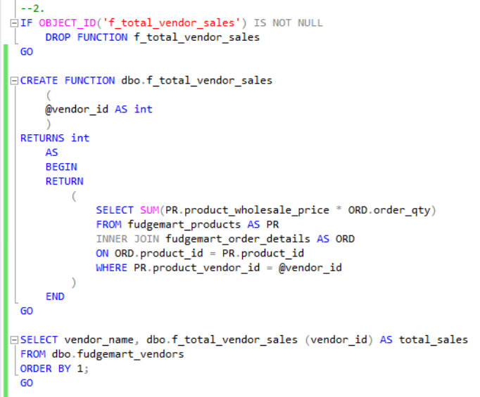
Again, I was close before the synch walkthrough. I loved discovering that you can alias using prefixes such as PR and ORD because it makes typing the code so much easier (Especially not having to type “fudge” so many times—I had an error where I had a typo in my spelling of fudge in “fudgemart_products” that I couldn’t figure out for almost 20 minutes).
3. 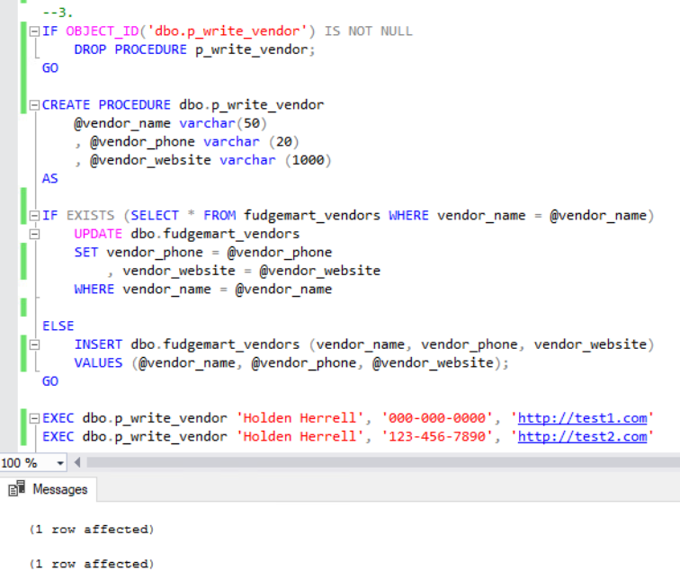

4. 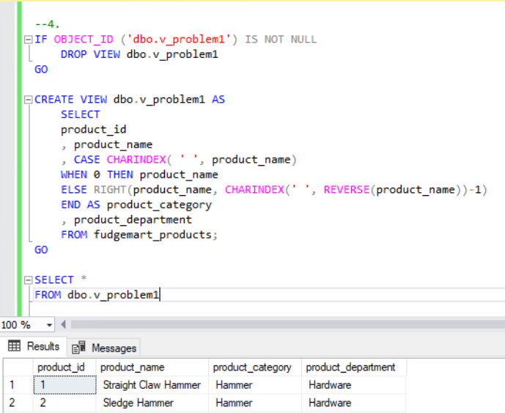
This was certainly the easiest of the problems in this lab.
5. 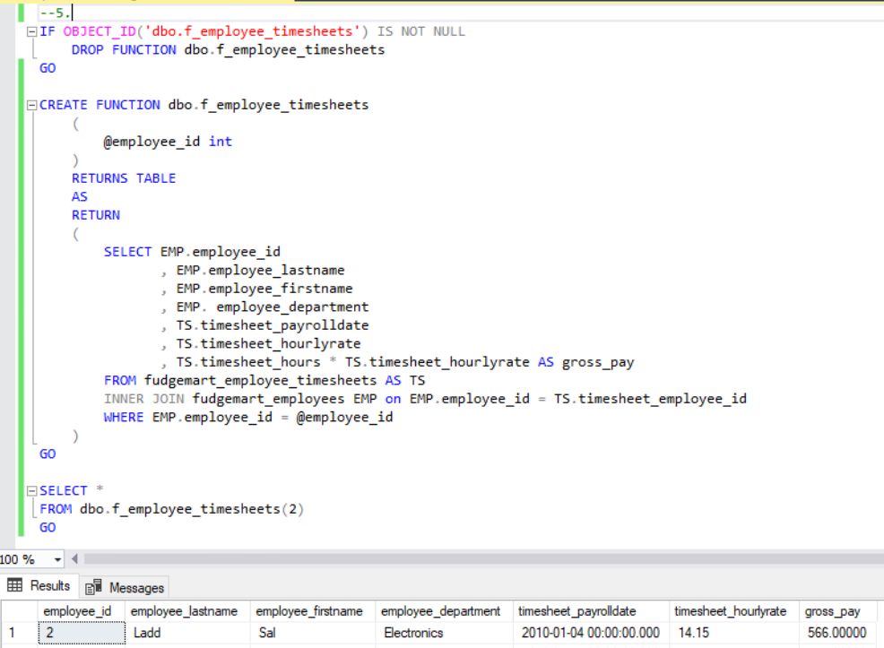
Again, I was glad to be able to alias instead of typing out the full table names so many times during this SELECT statement.

